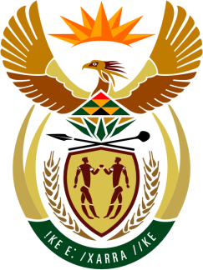

**SOUTH AFRICAN PERMANENT MISSION TO THE UNITED NATIONS AND**

**OTHER INTERNATIONAL ORGANISATIONS**

**27th SESSION OF THE WORKING GROUP ON THE UNIVERSAL PERIODIC REVIEW**

**Review of BRAZIL**

**05 MAY 2017**

**PALAIS DES NATIONS**

***Check against delivery***

Mr President,

South Africa welcomes the distinguished delegation of Brazil to this UPR Session and thanks the delegation for its detailed national report.

South Africa commends Brazil for its success in lifting some 36 million people out of extreme poverty in recent decades. We particularly commend the linking of the benefits of the Bolsa Familia Programme to school enrolment.

South Africa recognises Brazil’s efforts to promote racial equality through affirmative action for Afro-Brazilians, and the setting up of the National System for the Promotion of Racial Equality.

In order to further register progress, we recommend that Brazil:

1. Develop and implement policy to address child mortality, malnutrition, health, education and access to sanitation of indigenous people.
2. Address overcrowding, sanitation, violence, and medical and psychological care in prisons.
3. Address challenges of water and sanitation in favelas by full implementation of the National Sanitation Plan.

We wish Brazil a successful review during this Session.

I thank you.